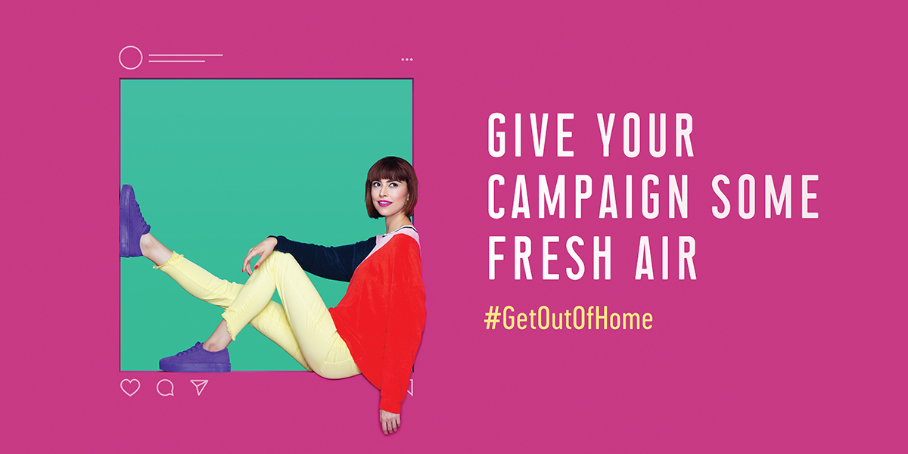
Out of Home (OOH) Industry Challenges [insert market] Ad Community to ‘Get Out of Home’
New Ad Campaign Targets Advertisers & Agencies
Explaining Why OOH is Significant in Today’s Digital World

[DATE], [Market] – The out of home (OOH) industry in [market], in partnership with the Outdoor Advertising Association of America, (OAAA) has launched a new campaign to inspire and excite the ad industry about OOH’s power, value, and significance in today’s digital world. The “Get Out of Home” campaign, created by agency of record Publicis New York, highlights how the medium competes with and complements online and mobile advertising. See work here: https://oaaa.sharefile.com/d-s2857456565347528
“Today’s advertising creatives and media planners grew up with the internet in the palm of their hands; they get digital media and push it forward,” said Stephen Freitas, OAAA’s chief marketing officer. “We want to show them some ideas are too big to stay trapped online. Bold ideas need a bold platform.”

Freitas added, “Our goal is to spark conversation about how today’s responsive, engaging OOH medium can elevate any idea, creating magnetism and distinction.”

Nationwide the campaign is featured on more than 50,000 OOH units, including 27 digital screen networks, in 30 major US markets. [OOH Media Company] is targeting the [market] ad industry with [number of faces] OOH locations.

[additional details about targeting specific agencies or advertisers]

[quote from OOH media company about participating in the campaign)

[sign locations]
Josh Horn, Creative Director, Publicis New York, commented, “OOH has become the ultimate stage for brands to get their message seen. It’s contextual, measurable and responsive. We wanted to celebrate its power to amplify today’s best campaigns."

ABOUT [Company Name]
[Company boilerplate]

ABOUT OAAA
The Outdoor Advertising Association of America (OAAA) is the national trade association for the $7.8 billion US out of home advertising (OOH) industry, which includes digital out of home (DOOH), and is comprised of billboards, street furniture, transit advertising, and place-based media. Comprised of 800+ member media companies, advertisers, agencies, ad-tech providers, and suppliers that represent over 90 percent of the industry, OAAA is a unified voice, an authoritative thought leader, and a passionate advocate that protects, unites, and advances OOH advertising in the United States. OAAA-member media companies donate over $500 million in public service advertising annually. Every year, the industry celebrates and rewards OOH creativity via its renowned OBIE Awards (obieawards.org). For more information, please visit oaaa.org.

ABOUT PUBLICIS WORLDWIDE
Publicis Worldwide is a global creative agency providing change leadership for its clients. We believe that this era demands a combination of strategy, creativity and technology to enable our clients to Lead The Change in their own marketing transformation. We provide global solutions from brand reputation to commerce. With over 16,000 employees in 110 countries, clients include Axa, BNP Paribas, Capital One, Carrefour, Cartier, Citi, Engie, Heineken, L'Oréal, Luxottica, LVMH, Nestlé, Orange, P&G, Qantas, Red Lobster, Renault, Samsung, Sanofi, Seb, Siemens, Telefonica, Total & UBS. Publicis Worldwide is part of Publicis Communications, the creative solution hub of Publicis Groupe. www.publicis.com | @PublicisWW | https://www.facebook.com/pages/Publicis-Worldwide/205430832807607?fref=ts

# # #
Contacts:
[contact details]

